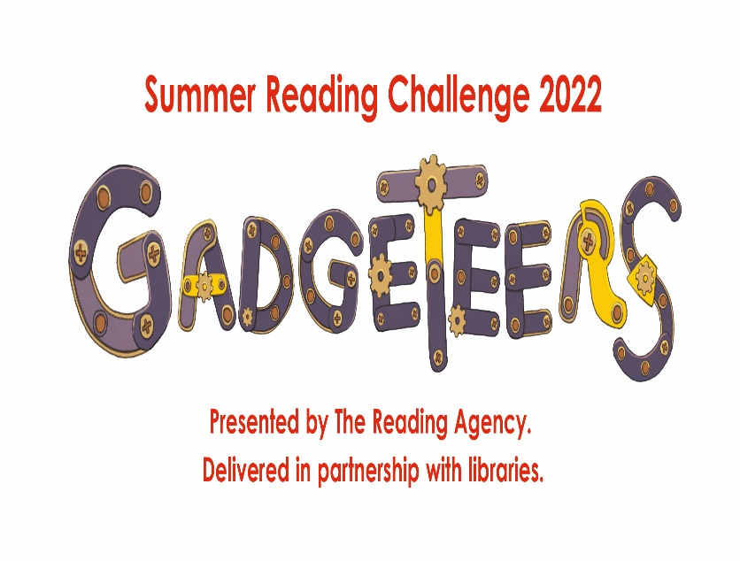

**Nottingham City Libraries Summer Reading Challenge.**

We challenge every Nottingham City child to read 6 books! Earn stickers and prizes along the way and collect a certificate and invite to a medal ceremony if you finish all 6 books! Continue reading to get your name into a prize draw for our 7+book challenge.

Lots of exciting activities are also happening across the libraries during the school holidays – head on down to your local library to pick up a leaflet or why not check out our website for more information.

**www.nottinghamcitylibraries.co.uk/summer-reading-challenge**